Version 1.4

FEB 2018



MILLERTECH

340 GRAYS INN ROAD

LONDON, WC1X 8BG

**CiviCRM Extension – COLLAPSE COMMS AND DEMOGRAPHICS**

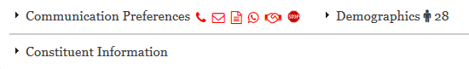

# **CiviCRM Extension – Collapse comms and demographics**

On many occasions, clients have mentioned that the contact summary screen loses a lot of prime space to the communication preferences and demographics sections.

“Is there no way to collapse them by default like you can with custom date? They are rarely used but are needed”

They’re aware that demographics and communication preferences can be removed via the UI (/civicrm/admin/setting/preferences/display?reset=1)

This is a simple extension that collapses both the communication preferences and demographics sections by default on the summary page.  
We’ve added a few fancy bits to the functionality which we’re sure you’ll enjoy…

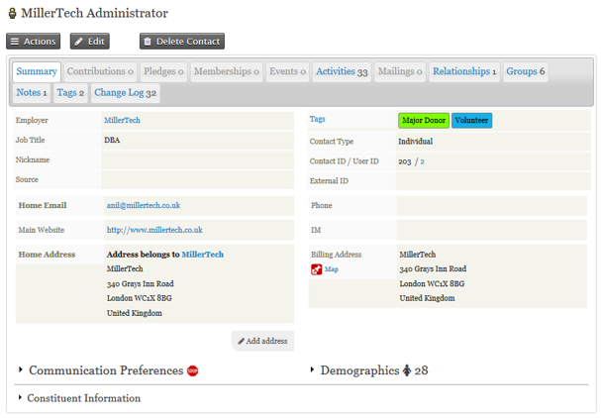

**Communication Preferences and Demographics are now collapsed by default.**

## Additional fancy bits –

Displays related icons next to the Communication Preferences collapsed heading if any of the 6 privacy options have been selected –

* Do not phone
* Do not email
* Do not mail
* Do not sms
* Do not trade
* NO BULK EMAILS (User Opt Out)



The applicable privacy setting text will appear on hover of the icons -

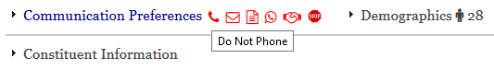

Displays the male or female icon next to the demographics collapsed heading if gender field has a value of female (1) or male (2), blank for any other value.  
Displays age of individual if there’s a value in the D.O.B field. Age is hidden if contact is flagged as deceased.

